# INTRODUCTION

* 1. Overview
  2. To make the existing app more efficient for the Job application we create custom objects and relationships to store and access the data more efficiently.

A brief description about your project

* 1. Create a CRM Application which helps the applicant to track the No. of jobs he applied and helps him to find the job posted by the various recruiters, find the best attributes to be involved to run the process in a smooth way and easily to track.
  2. Purpose
  3. This Project helps in managing the on-going and upcoming jobs in an various organization.

The use of this project. What can be achieved using this.

* Create and manage jobs applied details and status
* Useful to job seekers as well as job providers

1. **Problem Definition & Design Thinking**
   1. Empathy Map

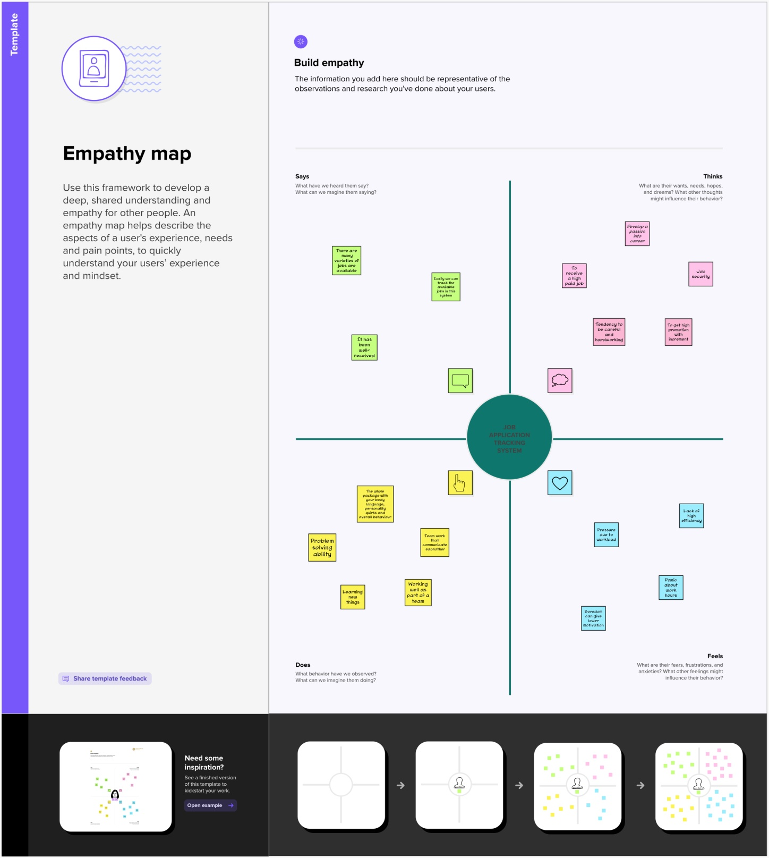

* 1. Ideation & Brainstorming Map

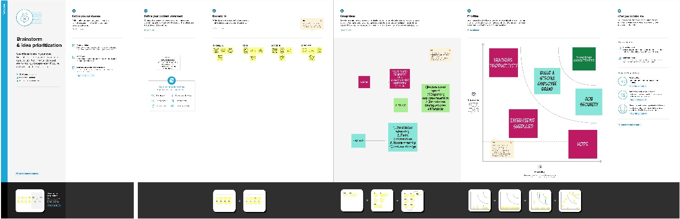

# RESULT

* 1. Data Model:

|  |  |
| --- | --- |
| Field label | Data type |
| City | Text |
| Phone number | Number |

|  |  |
| --- | --- |
| **Object name** | **Fields in the Object** |
| obj1  Events |  |
| obj2  Attendees | |  |  | | --- | --- | | Field label | Data type | | ID | Text | | Phone number | Number | | Email | Text | |
| Obj 3  Speakers | |  |  | | --- | --- | | Field label | Data type | | Name | Text | | Title | Text | |
| Obj 4  Vendors |  |

## Activity & Screenshot

|  |  |
| --- | --- |
| Field label | Data type |
| Name | Text |
| Title | Text |

## 

Attach the screenshots of your project activity along with the description.

## Trailhead Profile Public URL

**Team Lead -**<https://trailblazer.me/id/hdivakaran>

**Team Member 1 -**<https://trailblazer.me/id/mdinesh29>

**Team Member 2 -** <https://trailblazer.me/id/gmalaiyappan>

**Team Member 3 –**<https://trailblazer.me/id/gkarthick43>

# ADVANTAGES & DISADVANTAGE

List of advantages

* designed to help individual job seekers
* It is used to employer as well as employee

List of disadvantages

* Individual data can be available in public or private
* Frequent updating is mandatory

# APPLICATIONS

* This CRM simply the employer job to recruit the right persons
* This CRM help job seekers apply various jobs in short span of time

1. **CONCLUSION**

This Project helps in managing the on-going and upcoming jobs in an various organizations in national and international level

# FUTURE SCOPE

It can be developed in agricultural based employability in future. This much useful to farmers